Digital Communication

**Lab Assignment: 7**

**Name: Darshana Chauhan**

**Student ID: 202101467**

**Lab Group: 5**

**Exercise: 1:**

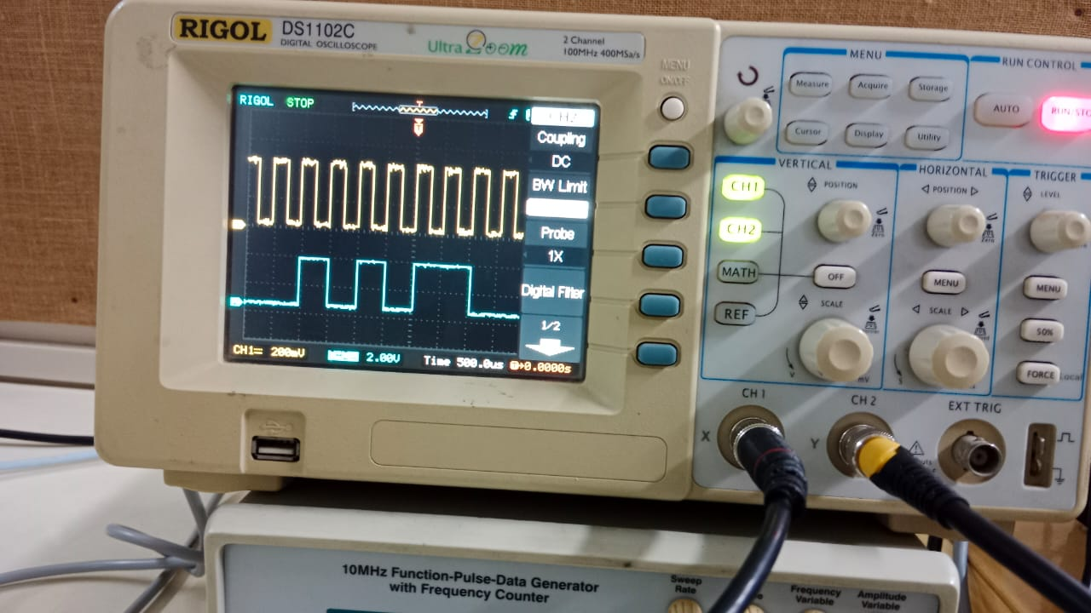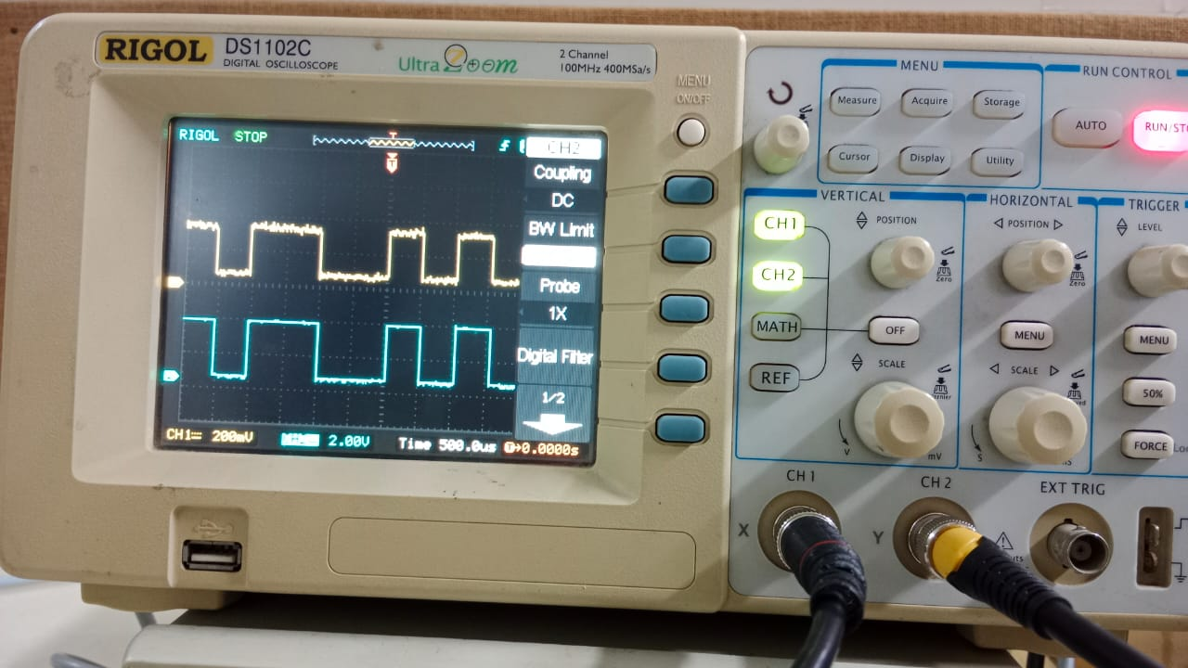

**Exercise: 2:**

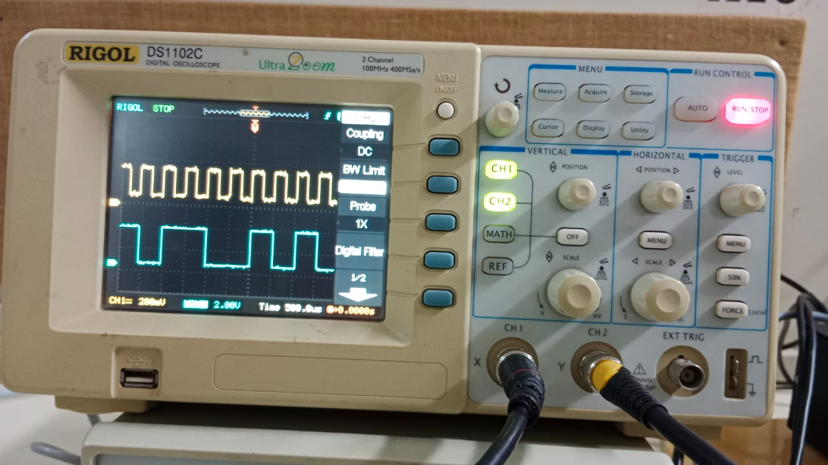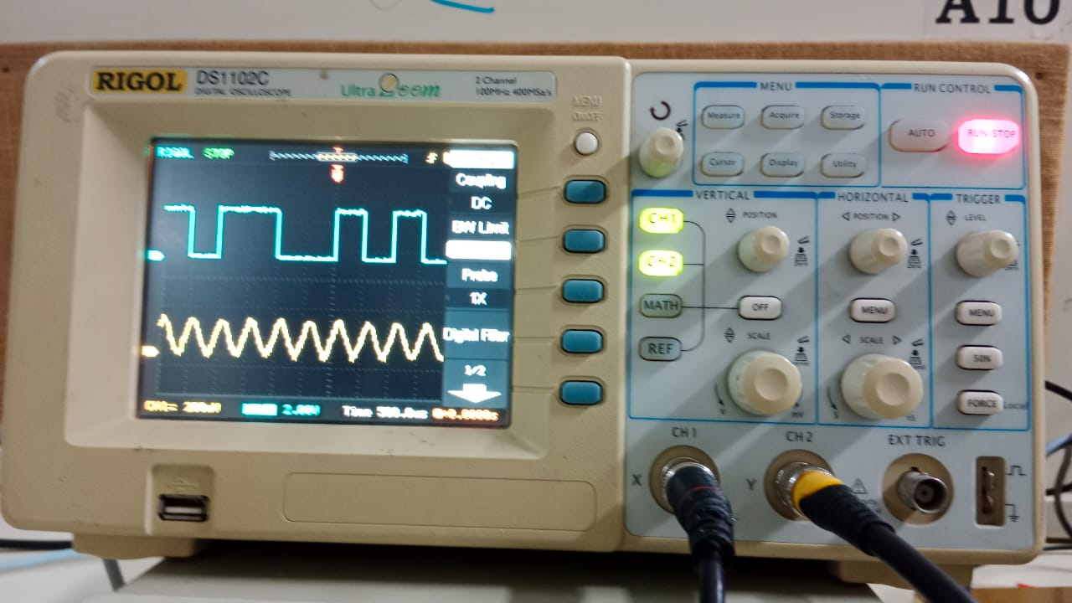

**Exercise: 3:**

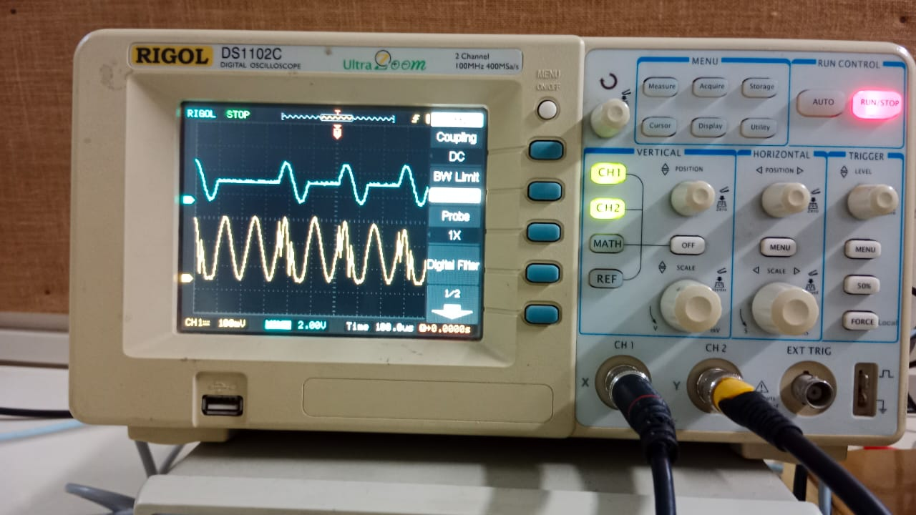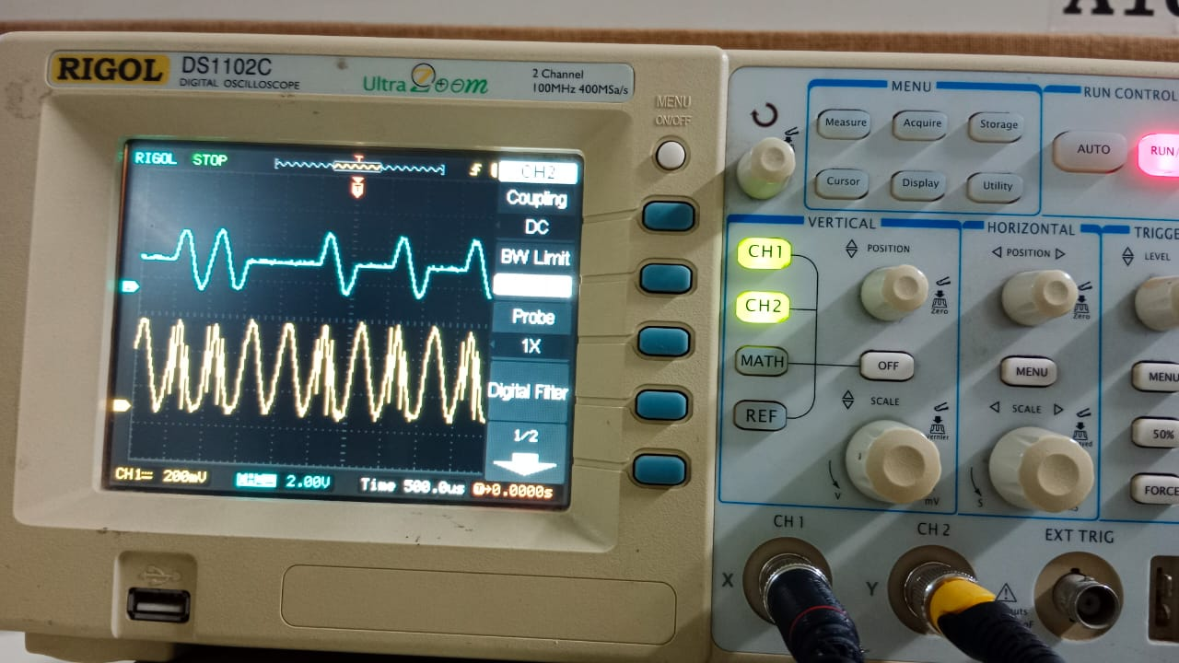

**Exercise: 4:**

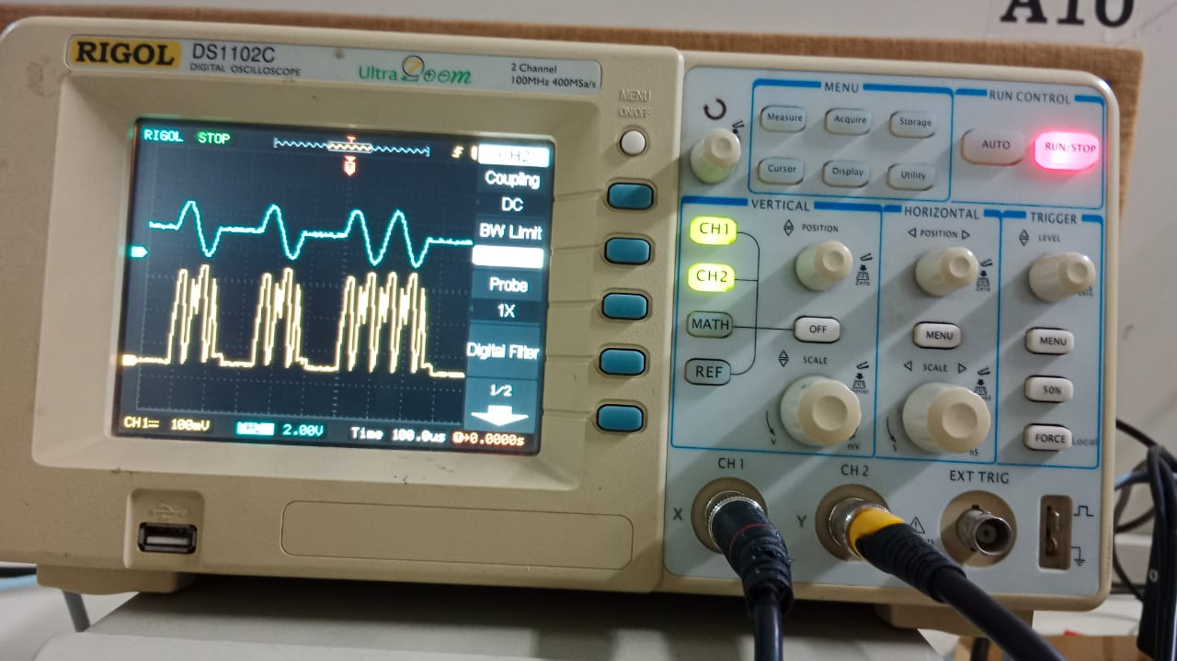 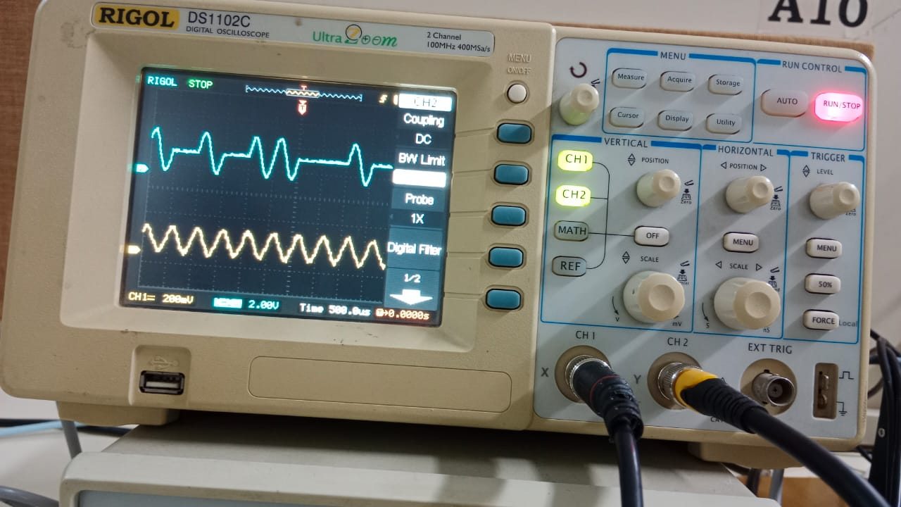

**Exercise: 5:**

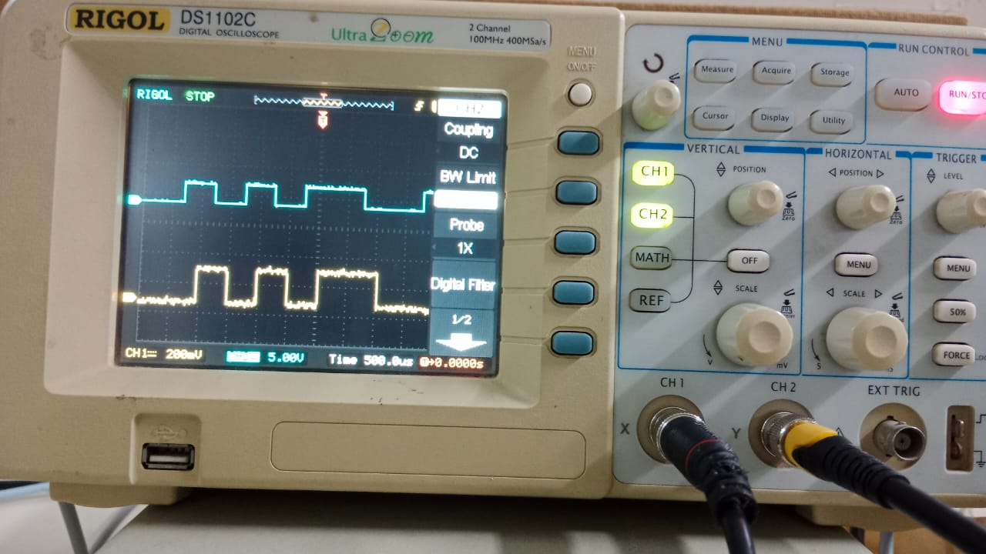

**Exercise: 6:**

 

**Experiment: 2:**

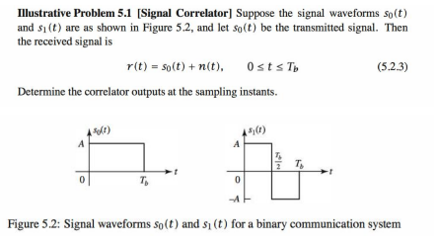

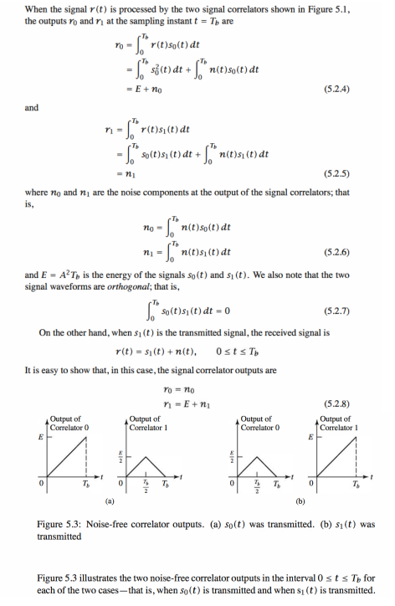

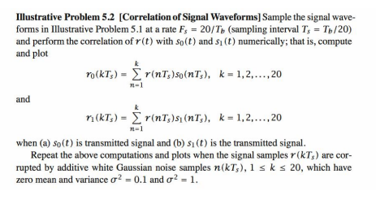

**Illustrative Example: 5.2:**

% MATLAB script for Illustrative Problem 5.2

% Initialization:

K = 20; % Number of samples

A = 1; % Signal amplitude

l = 0:K;

% Defining signal waveforms:

s_0 = A * ones(1, K);

s_l = [A * ones(1, K/2) -A * ones(1, K/2)];

% Initializing output signals:

r_0 = zeros(1, K);

r_l = zeros(1, K);

% Case 1: noise-N(0,0)

noise = random('Normal', 0, 0, 1, K);

% Sub-case s = s_0:

s = s_0;

r = s + noise; % received signal

for n = 1:K

r_0(n) = sum(r(1:n) .* s_0(1:n));

r_l(n) = sum(r(1:n) .* s_l(1:n));

end

% Plotting the results:

subplot(3,2,1)

plot(l, [0 r_0], ' -', l, [0 r_l], ' --')

set(gca, 'XTickLabel', {'0', '5Tb', '10Tb', '15Tb', '20Tb'})

axis([0 20 -5 30])

xlabel('(a) \σ^2= 0 & S_{0} is transmitted','fontsize',10)

% Sub-case s = s_l:

s = s_l;

r = s + noise; % received signal

for n = 1:K

r_0(n) = sum(r(1:n) .* s_0(1:n));

r_l(n) = sum(r(1:n) .* s_l(1:n));

end

% Plotting the results:

subplot(3,2,2)

plot(l, [0 r_0], ' -', l, [0 r_l], ' --')

set(gca, 'XTickLabel', {'0', '5Tb', '10Tb', '15Tb', '20Tb'})

axis([0 20 -5 30])

xlabel('(b) \σ^2= 0 & S_{l} is transmitted','fontsize',10)

% Case 2: noise-N(0,0.1)

noise = random('Normal', 0, 0.1, 1, K);

% Sub-case s = s_0:

s = s_0;

r = s + noise; % received signal

for n = 1:K

r_0(n) = sum(r(1:n) .* s_0(1:n));

r_l(n) = sum(r(1:n) .* s_l(1:n));

end

% Plotting the results:

subplot(3,2,3)

plot(l, [0 r_0], ' -', l, [0 r_l], ' --')

set(gca, 'XTickLabel', {'0', '5Tb', '10Tb', '15Tb', '20Tb'})

axis([0 20 -5 30])

xlabel('(c) \σ^2= 0.1 & S_{0} is transmitted','fontsize',10)

% Sub-case s = s_l:

s = s_l;

r = s + noise; % received signal

for n = 1:K

r_0(n) = sum(r(1:n) .* s_0(1:n));

r_l(n) = sum(r(1:n) .* s_l(1:n));

end

% Plotting the results:

subplot(3,2,4)

plot(l, [0 r_0], ' -', l, [0 r_l], ' --')

set(gca, 'XTickLabel', {'0', '5Tb', '10Tb', '15Tb', '20Tb'})

axis([0 20 -5 30])

xlabel('(d) \σ^2= 0.1 & S_{l} is transmitted','fontsize',10)

% Case 3: noise-N(0,1)

noise = random('Normal', 0, 1, 1, K);

% Sub-case s = s_0:

s = s_0;

r = s + noise; % received signal

for n = 1:K

r_0(n) = sum(r(1:n) .* s_0(1:n));

r_l(n) = sum(r(1:n) .* s_l(1:n));

end

% Plotting the results:

subplot(3,2,5)

plot(l, [0 r_0], ' -', l, [0 r_l], ' --')

set(gca, 'XTickLabel', {'0', '5Tb', '10Tb', '15Tb', '20Tb'})

axis([0 20 -5 30])

xlabel('(e) \σ^2= 1 & S_{0} is transmitted','fontsize',10)

% Sub-case s = s_l:

s = s_l;

r = s + noise; % received signal

for n = 1:K

r_0(n) = sum(r(1:n) .* s_0(1:n));

r_l(n) = sum(r(1:n) .* s_l(1:n));

end

% Plotting the results:

subplot(3,2,6)

plot(l, [0 r_0], ' -', l, [0 r_l], ' --')

set(gca, 'XTickLabel', {'0', '5Tb', '10Tb', '15Tb', '20Tb'})

axis([0 20 -5 30])

xlabel('(f) \σ^2= 1 & S_{l} is transmitted','fontsize',10)

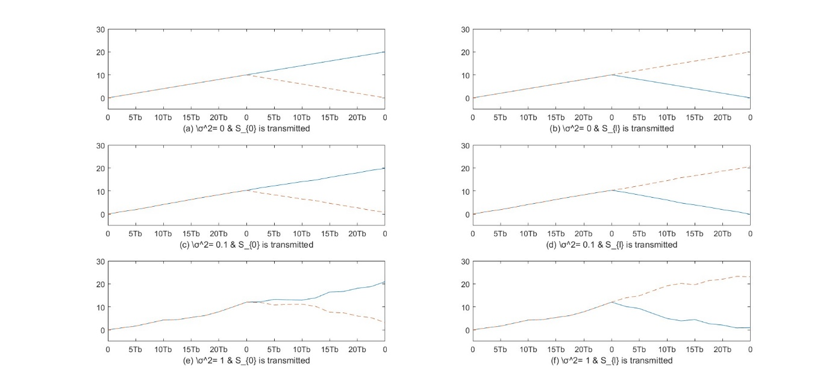

**Example: 5.3:**

% MATLAB script for Illustrative Problem 5.2

% Initialization:

K = 20; % Number of samples

A = 1; % Signal amplitude

l = 0:K;

% Defining signal waveforms:

s_0 = A * ones(1, K);

s_l = [A * ones(1, K/2) -A * ones(1, K/2)];

% Noise variances to test

noise_variances = [0.1, 1, 3];

for sigma2 = noise_variances

% Initializing output signals:

r_0 = zeros(1, K);

r_l = zeros(1, K);

% Generating noise

noise = random('Normal', 0, sqrt(sigma2), 1, K);

% Sub-case s = s_0:

s = s_0;

r = s + noise; % received signal

for n = 1:K

r_0(n) = sum(r(1:n) .* s_0(1:n));

r_l(n) = sum(r(1:n) .* s_l(1:n));

end

% Plotting the results:

figure;

subplot(2,1,1);

plot(l, [0 r_0], ' -', l, [0 r_l], ' --')

set(gca, 'XTickLabel', {'0', '5Tb', '10Tb', '15Tb', '20Tb'})

title(['\sigma^2 = ' num2str(sigma2) ' & S_{0} is transmitted'])

xlabel('Time')

ylabel('Correlation Output')

legend('Correlation with S_{0}', 'Correlation with S_{l}')

grid on;

% Sub-case s = s_l:

s = s_l;

r = s + noise; % received signal

for n = 1:K

r_0(n) = sum(r(1:n) .* s_0(1:n));

r_l(n) = sum(r(1:n) .* s_l(1:n));

end

% Plotting the results:

subplot(2,1,2);

plot(l, [0 r_0], ' -', l, [0 r_l], ' --')

set(gca, 'XTickLabel', {'0', '5Tb', '10Tb', '15Tb', '20Tb'})

title(['\sigma^2 = ' num2str(sigma2) ' & S_{l} is transmitted'])

xlabel('Time')

ylabel('Correlation Output')

legend('Correlation with S_{0}', 'Correlation with S_{l}')

grid on;

end

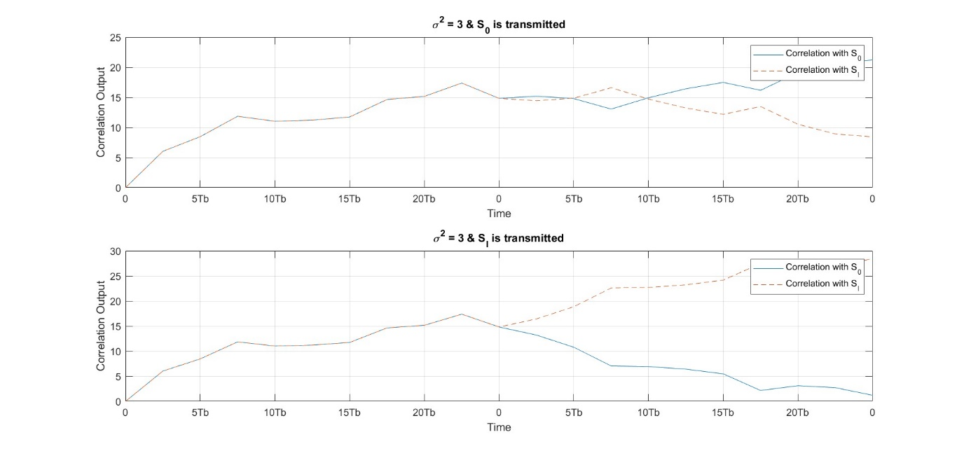

**Experiment: 3:**

**Illustrative Example: 5.3:**

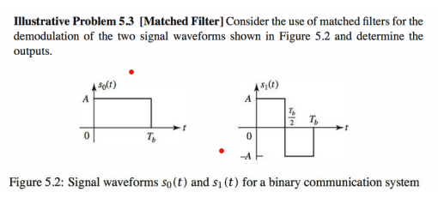

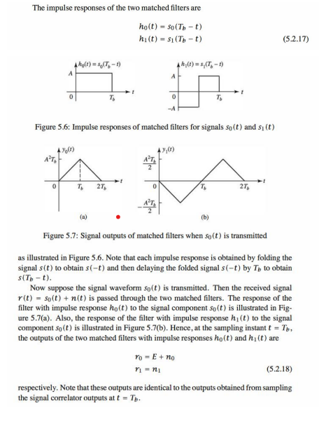

**Illustrative Example: 5.4:**

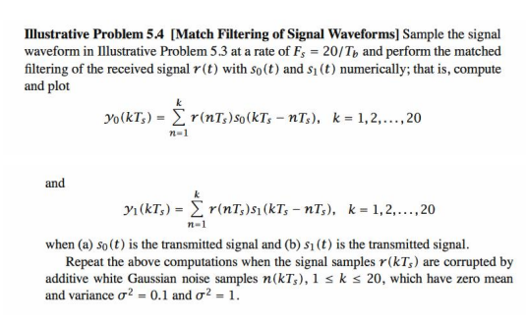

% MATLAB script for Illustrative Problem 5.4.

% Initialization:

K = 20; % Number of samples

A = 1;

l = 0:K;

% Signal amplitude

% Defining signal waveforms:

s_O = A * ones(1, K);

s_l = [A * ones(1, K/2) -A * ones(1, K/2)];

% Initializing output signals:

y_O = zeros(1, K);

y_l = zeros(1, K);

% Case 1: noise-N(0,0)

noise = random('Normal', 0, 0, 1, K);

% Sub-case s = s_O:

s = s_O;

y = s + noise; % received signal

y_O = conv(y, wrev(s_O));

y_l = conv(y, wrev(s_l));

% Plotting the results:

subplot(3, 2, 1)

plot(l, [0 y_O(1:K)], '-k', l, [0 y_l(1:K)], '--k')

set(gca, 'XTickLabel', {'0', '5Tb', '10Tb', '15Tb', '20Tb'})

axis([0 20 -30 30])

xlabel('(a) \sigmaA2= 0 & S {O} is transmitted','fontsize',10)

% Sub-case s = s_l:

s = s_l;

y = s + noise; % received signal

y_O = conv(y, wrev(s_O));

y_l = conv(y, wrev(s_l));

% Plotting the results:

subplot(3, 2, 2)

plot(l, [0 y_O(1:K)], '-k', l, [0 y_l(1:K)], '--k')

set(gca, 'XTickLabel', {'0', 'STb', '10Tb', '15Tb', '20Tb'})

axis([0 20 -30 30])

xlabel('(b) \sigmaA2= 0 & S_{l} is transmitted','fontsize',10)

% Case 2: noise-N(0,0.1)

noise = random('Normal', 0, 0.1, 1, K);

% Sub-case s = s_O:

s = s_O;

y = s + noise; % received signal

y_O = conv(y, wrev(s_O));

y_l = conv(y, wrev(s_l));

% Plotting the results:

subplot(3, 2, 3)

plot(l, [0 y_O(1:K)], '-k', l, [0 y_l(1:K)], '--k')

set(gca, 'XTickLabel', {'0', '5Tb', '10Tb', '15Tb', '20Tb'})

axis([0 20 -30 30])

1

xlabel('(c) \sigmaA2= 0.1 & S_{O} is transmitted','fontsize',10)

% Sub-case s = s_l:

s = s_l;

y = s + noise; % received signal

y_O = conv(y, wrev(s_O));

y_l = conv(y, wrev(s_l));

% Plotting the results:

subplot(3, 2, 4)

plot(l, [0 y_O(1:K)], '-k', l, [0 y_l(1:K)], '--k')

set(gca, 'XTickLabel', {'0', '5Tb', '10Tb', '15Tb', '20Tb'})

axis([0 20 -30 30])

xlabel('(d) \sigmaA2= 0.1 & S_{l} is transmitted','fontsize',10)

% Case 3: noise-N(0,1)

noise = random('Normal', 0, 1, 1, K);

% Sub-case s = s_O:

s = s_O;

y = s + noise; % received signal

y_O = conv(y, wrev(s_O));

y_l = conv(y, wrev(s_l));

% Plotting the results:

subplot(3, 2, 5)

plot(l, [0 y_O(1:K)], '-k', l, [0 y_l(1:K)], '--k')

set(gca, 'XTickLabel', {'0', '5Tb', '10Tb', '15Tb', '20Tb'})

axis([0 20 -30 30])

xlabel('(e) \sigmaA2= 1 & S {O} is transmitted','fontsize',10)

% Sub-case s = s_l:

s = s_l;

y = s + noise; % received signal

y_O = conv(y, wrev(s_O));

y_l = conv(y, wrev(s_l));

% Plotting the results:

subplot(3, 2, 6)

plot(l, [0 y_O(1:K)], '-k', l, [0 y_l(1:K)], '--k')

set(gca, 'XTickLabel', {'0', '5Tb', '10Tb', '15Tb', '20Tb'})

axis([0 20 -30 30])

xlabel('(f) \sigmaA2= 1 & S_{l} is transmitted','fontsize',10)

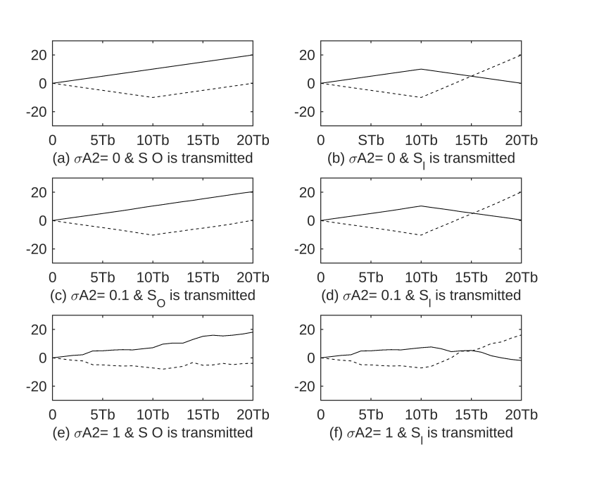

**Example: 5.4:**

% MATLAB script for Illustrative Problem 5.4.

% Initialization:

K = 20; % Number of samples

A = 1;

l = 0:K;

% Signal amplitude

% Defining signal waveforms:

s_O = A * ones(1, K);

s_l = [A * ones(1, K/2) -A * ones(1, K/2)];

% Initializing output signals:

y_O = zeros(1, K);

y_l = zeros(1, K);

% Define different noise variances

noise_variances = [0.1, 1, 3];

for sigma_squared = noise_variances

% Generate noise based on the current variance

noise = random('Normal', 0, sqrt(sigma_squared), 1, K);

% Sub-case s = s_O:

s = s_O;

y = s + noise; % received signal

y_O = conv(y, wrev(s_O));

y_l = conv(y, wrev(s_l));

% Plotting the results for each variance:

figure;

subplot(2, 1, 1);

plot(l, [0 y_O(1:K)], '-k', l, [0 y_l(1:K)], '--k');

set(gca, 'XTickLabel', {'0', '5Tb', '10Tb', '15Tb', '20Tb'});

axis([0 20 -30 30]);

title(['Matched Filter Output for \sigma^2 = ', num2str(sigma_squared),

' & S_O is transmitted']);

% Sub-case s = s_l:

s = s_l;

y = s + noise; % received signal

y_O = conv(y, wrev(s_O));

y_l = conv(y, wrev(s_l));

subplot(2, 1, 2);

plot(l, [0 y_O(1:K)], '-k', l, [0 y_l(1:K)], '--k');

set(gca, 'XTickLabel', {'0', '5Tb', '10Tb', '15Tb', '20Tb'});

axis([0 20 -30 30]);

title(['Matched Filter Output for \sigma^2 = ', num2str(sigma_squared),

' & S_{l} is transmitted']);

end

